LEGALSUITE DAILY REPORTS

SFTP details:
Host: 197.189.198.106
Username: lswapt@iconis.co.za
Password: 4Ax5Qqr0V8eT0rGR3z7fvW5x

Panel L & Debt Review

PTP APT FILES
CLOSED APT FILES
HANDOVER APT FILES
REOPEN APT FILES
FEEDBACK APT FILES
POC AND SUMMONS
CLAIM AMOUNT FILE

- PTP Files (Debt Review/ Panel L)
- Delete the column headings row
- Remove any apostrophes from the account numbers
- Save the file

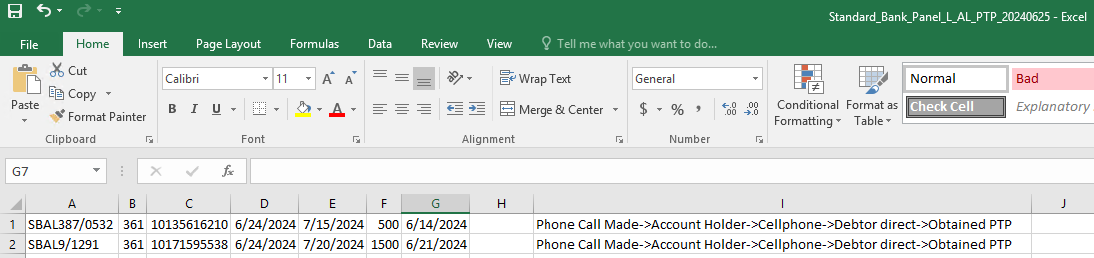

Import PTP Files (Debt Review/ Panel L)

- Navigate to File → Import/Export → Import Extra Screen Data.

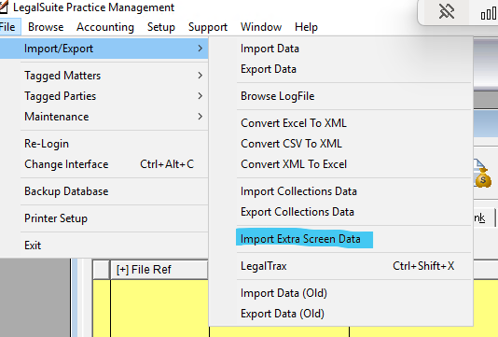

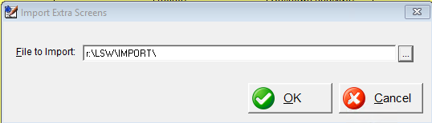

- Click the button to select a file.

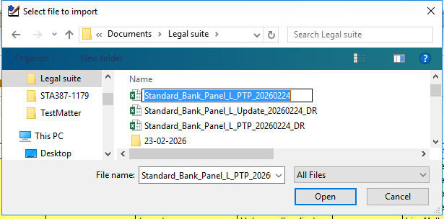

- A file explorer window will open.
- Locate and select the saved file, then click Open.
- Click ok to begin the import
- The file will begin importing, when the import has completed the window will close.

- Closed APT Files (Debt Review – Panel L)

- Locate the Matter in LegalSuite
- Search for the matter using the File Reference.
- Archive the Matter
- Navigate to Miscellaneous Tab → Current Status
- Change the status to Archived
- Enter the Closed Date
- Click Ok to save the changes
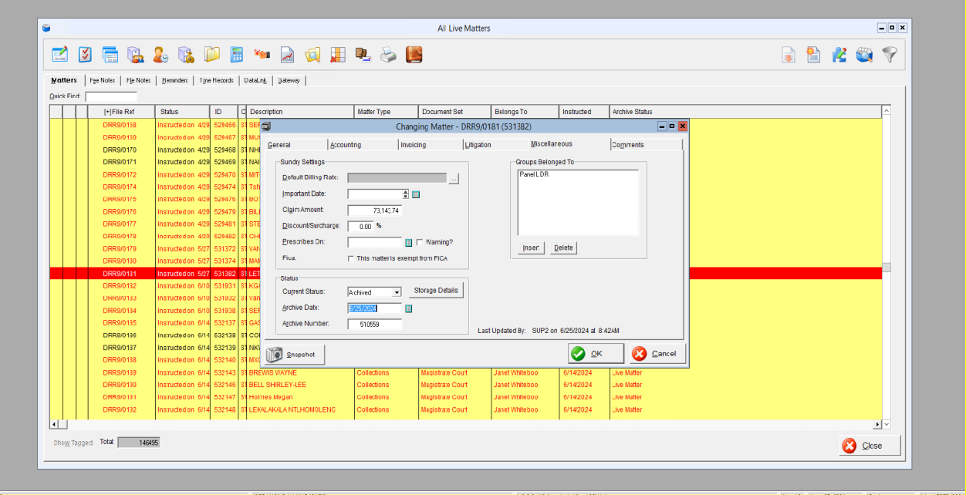

- Handover File (Debt Review – Panel L)

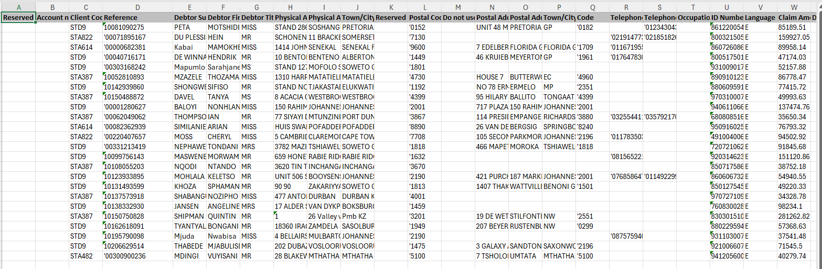
- Remove Apostrophes (Without Removing Zeros)
If account numbers or references start with a zero:
Manual fix
- Double-click the cell to remove the apostrophe (zero will remain)
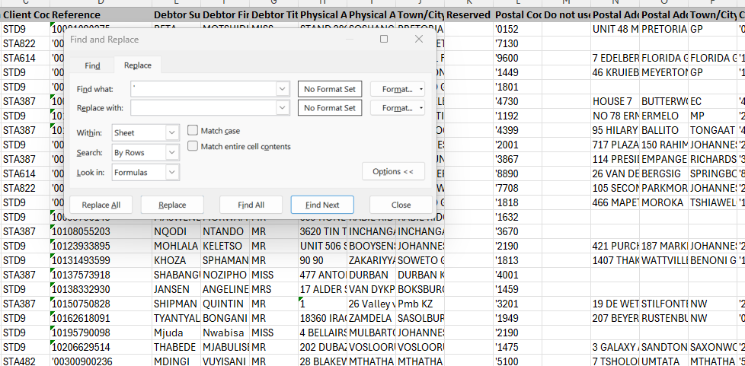

  - Replace All
- Open Find & Replace
- Replace ' with blank
- ⚠️ Ensure leading zeros remain intact

  - Format Columns
Account/Reference Numbers:
- Copy Reference Numbers
- Paste under Account Number Column

  - ID Number Column:
- Select column → Format Cells
- Choose Number
- Set Decimal Places = 0

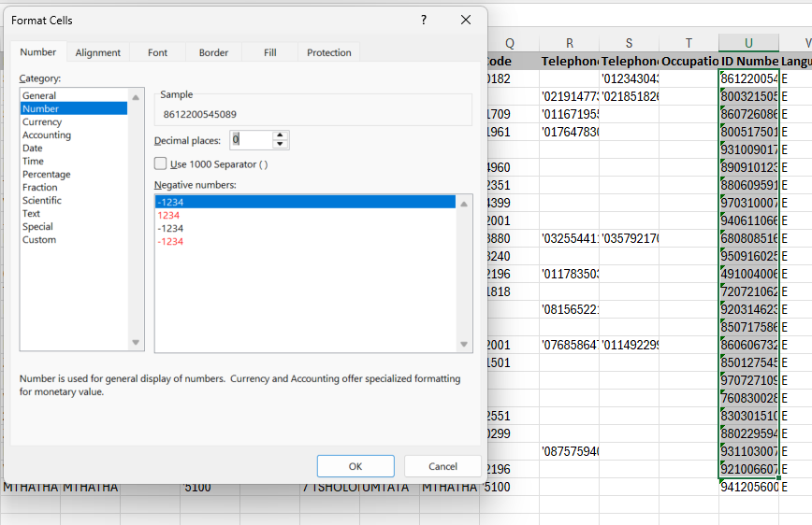

Date Columns:
- Select column → Format Cells
- Change to Date format

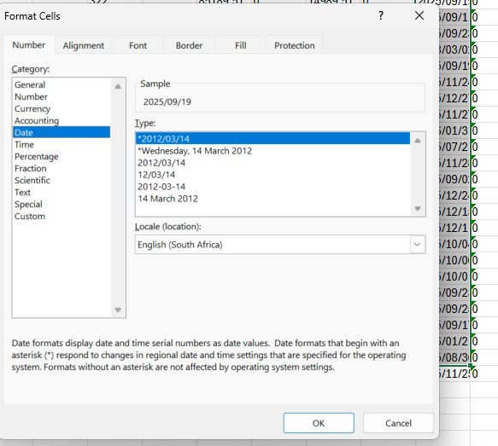

Importing the File
- Go to:
File → Import Collections Data
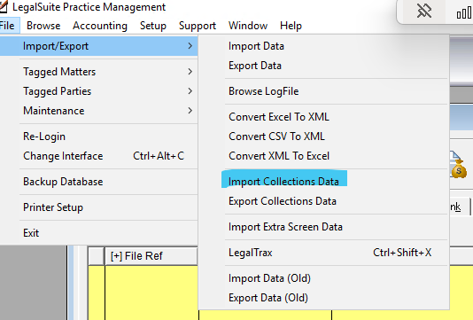

- Select the prepared file

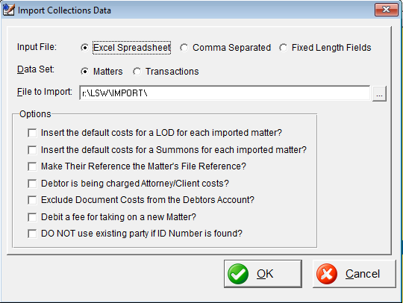
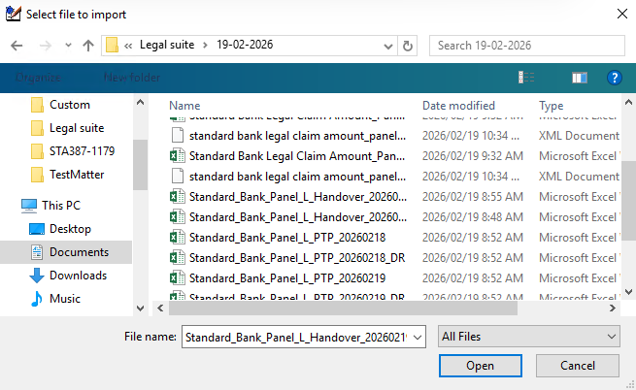

- Complete the import

Modify Tagged Matters
Once file is imported, select File -> Modify tagged matters
Select the below on the General Tab

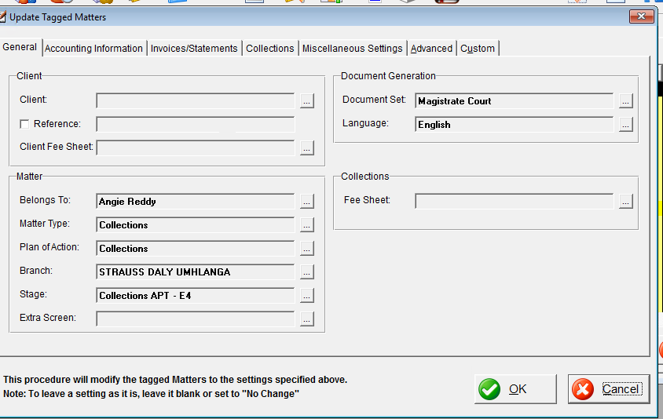

Accounting Information Tab

- Select the below
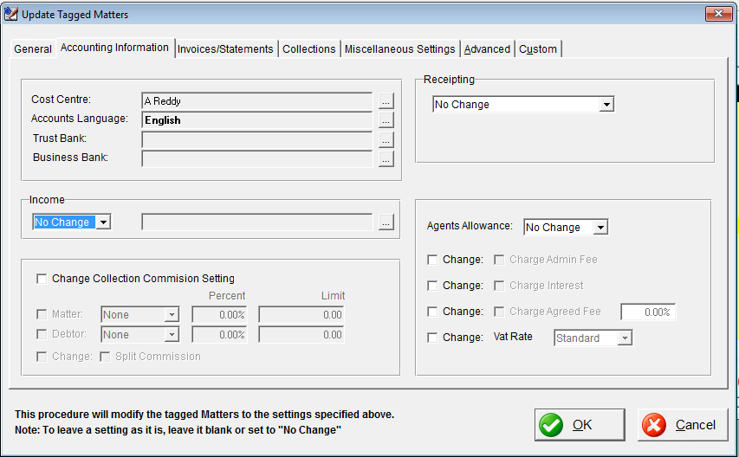

- Click okay

- Generate ADHOC Report

- Print Icon Button  → ADHOC REPORT
- Select Print Tagged Matters Only
Include:

- Matter File Reference

- Their Reference

- Matter Description

- Date Instructed

- Print and send to:
- tnxumalo@straussdaly.co.za
- areddy@straussdaly.co.za
- gharris@straussdaly.co.za
- defbloem@straussdaly.co.za

- CC: agashnee.pillay@iconis.co.za
- CC: thileshnee.chinnasamy@iconis.co.za

Refer to the email below for context

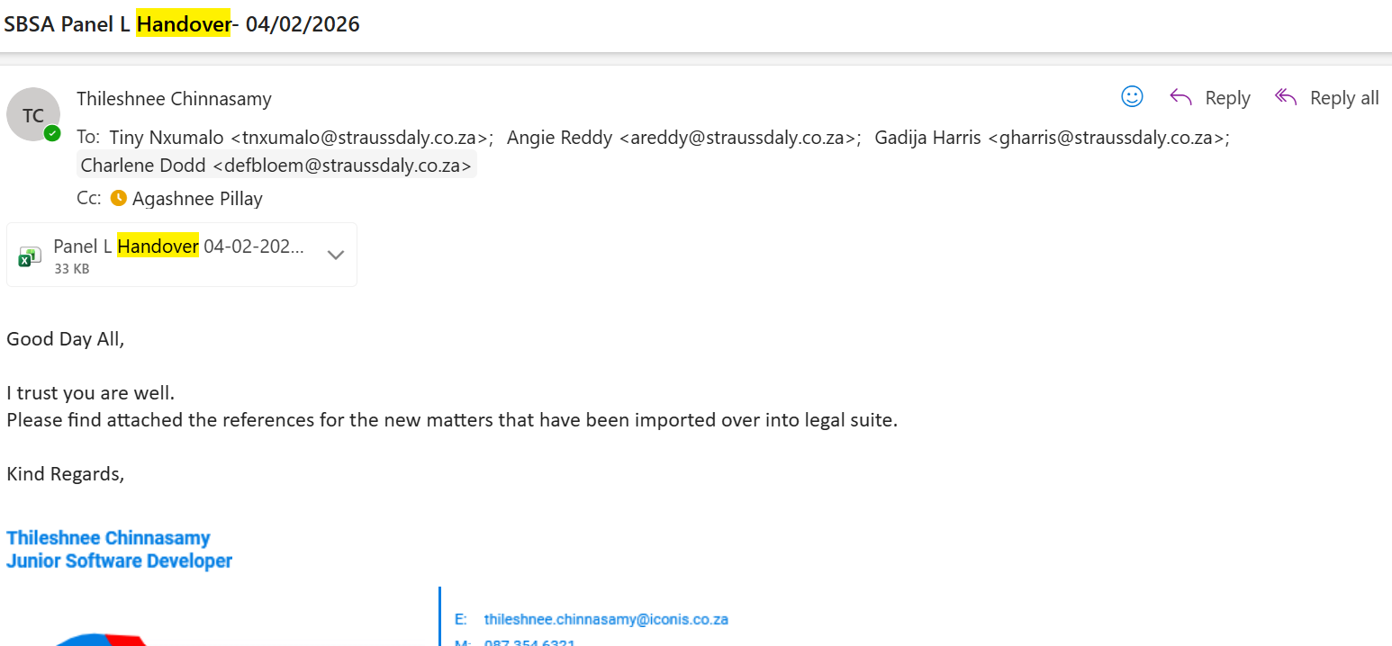

- Generate Report for Traq


Print Icon Button - ADHOC REPORT

- Select Print Tagged Matters Only
Include
- Matter File Reference
- Their Reference

- Save file as:
Panel_L_Handover_Report_20260216 (customise to date that the report was generated)

- Upload File

- Drop the saved report into the SFTP folder: Matter Ref Updates

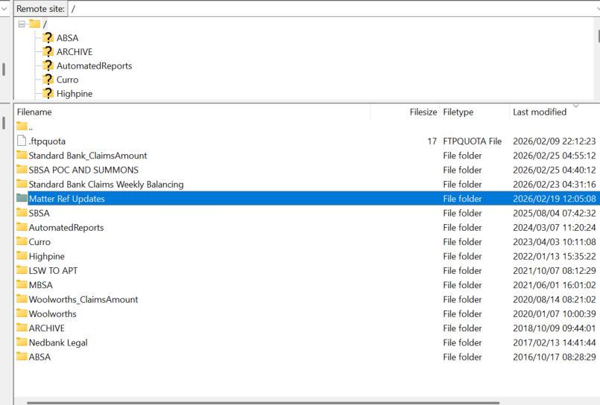

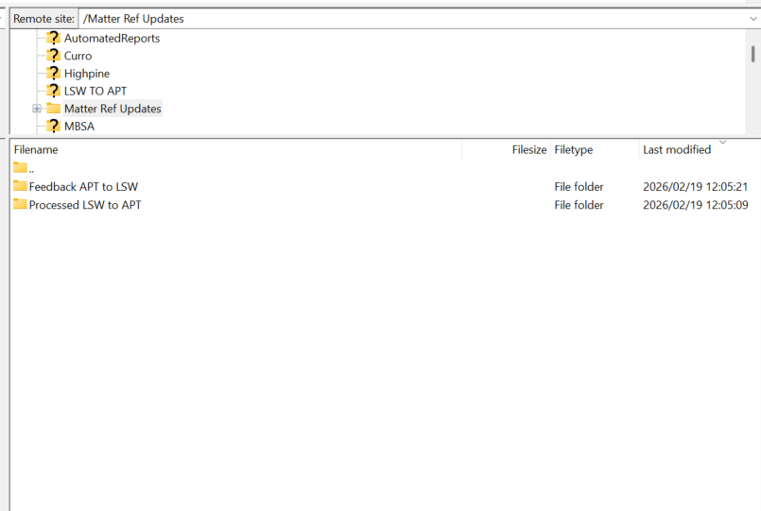
Don’t drop file into any of the subfolders, drop file directly into Matter Ref Updates

- On the day the handover is received, you may notice that the claims file contains blank file reference fields.
- Once the handover has been successfully imported:
- Match each account number to the newly generated reference number in LegalSuite.
- Add the file reference

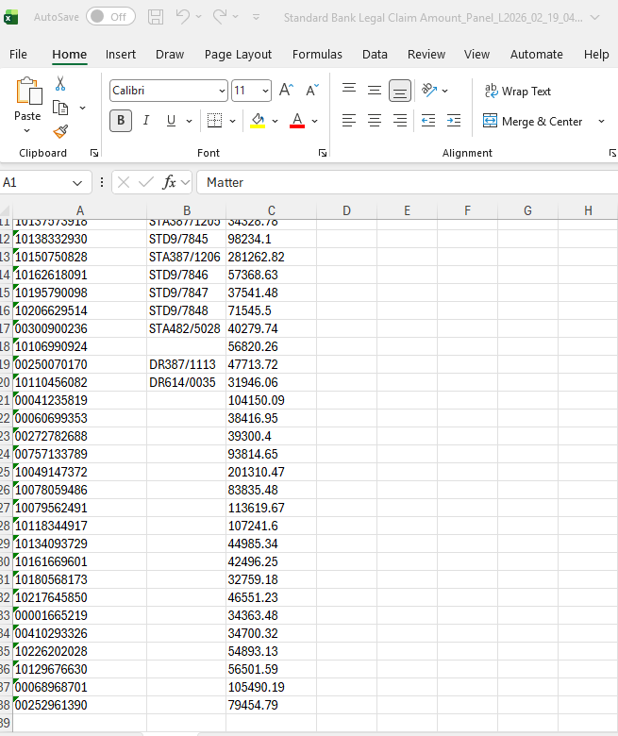

- Select Matter Column and clear contents
- Matter column must be empty
- Import the updated claims file into the system.

- STD bank Claims Amount - PANEL L

- Select Matter Column and clear contents

- Matter column must be empty

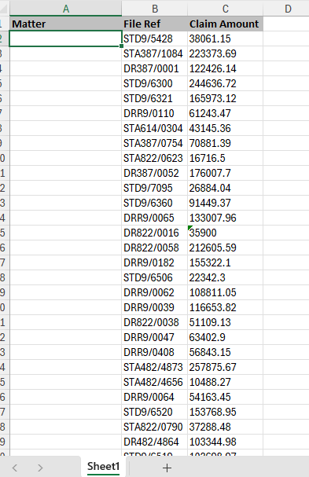

Import Claim File
- File->Import Data

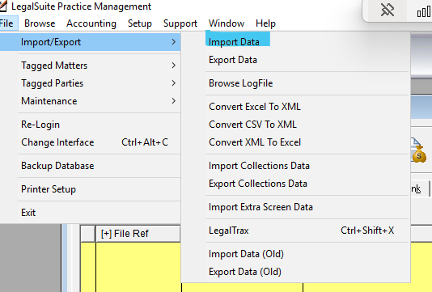

- Select the prepared file

- 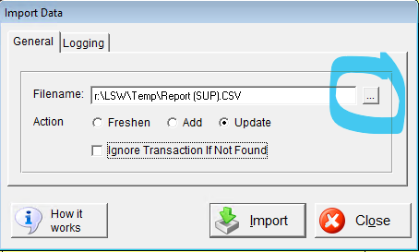

- Tick ignore transaction if found

- Select Import

- The file will begin importing, once import is complete close window.

- SBSA POC AND SUMMONS

- Delete column headings row
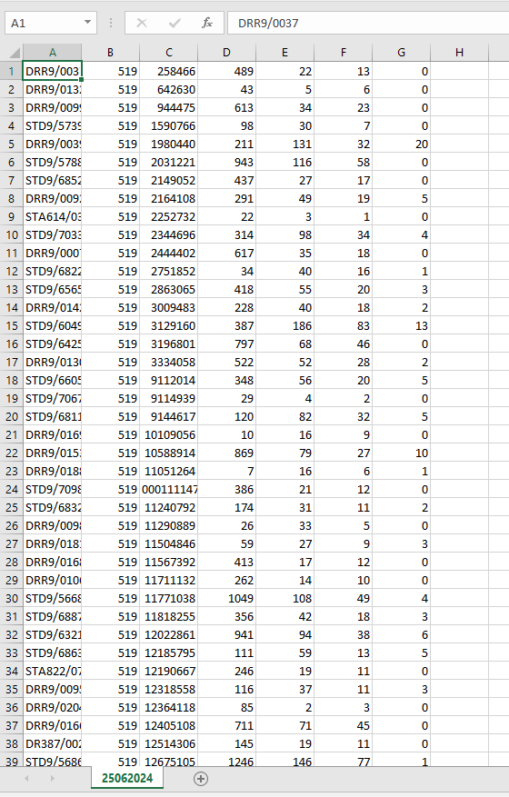
- Save file and change file type to excel workbook

Import POC and Summons file

- Navigate to File → Import/Export → Import Extra Screen Data.





- Click the button to select a file.



- Cheques Schedule (Sent to helpdesk from Collections)

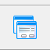
- Search for the account number
Click on the third tab

- APT Ext to LSW Multi – Call center extra screen
- LSW PTP to APT Mult – Litigation extra screen
- Check who has the arrangement first and it will belong to them
- Example: The below is the call center they never made any arrangements for payment recently as you see below its was 2023
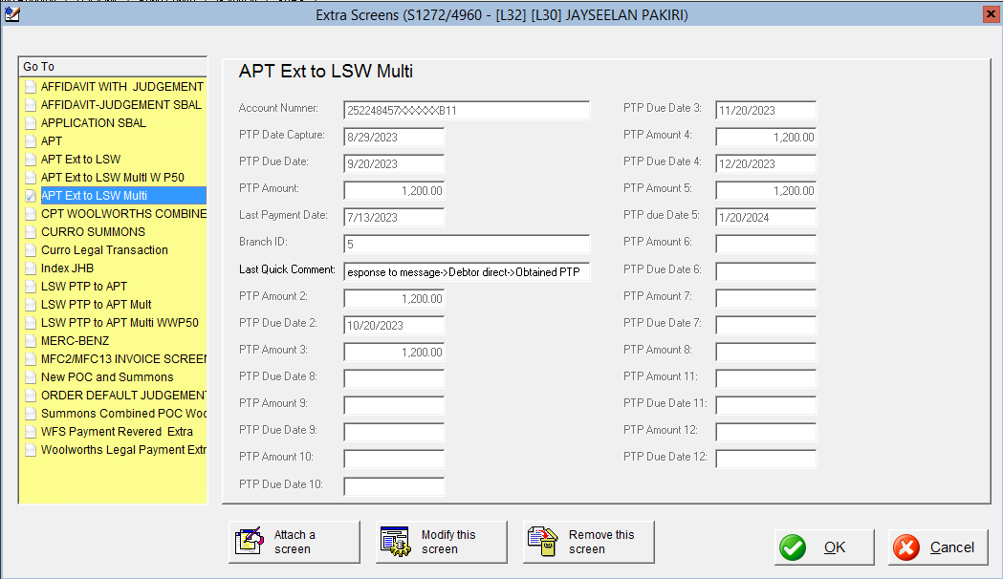

Collection Tab
- As you can see below collections recently arranged for payments So this PTP belong to Litigation
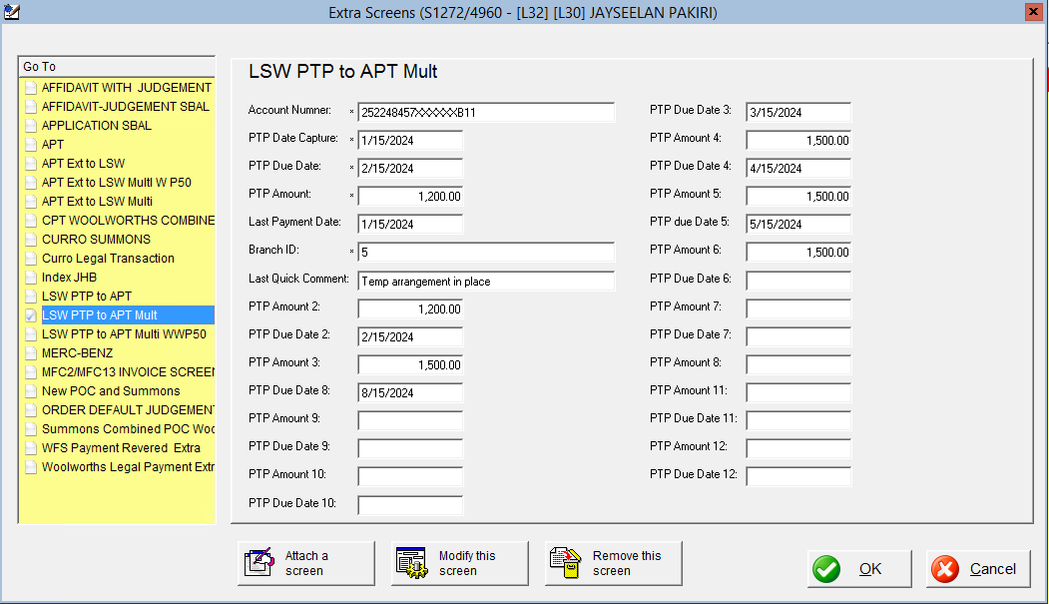

- Mark on the spreadsheet
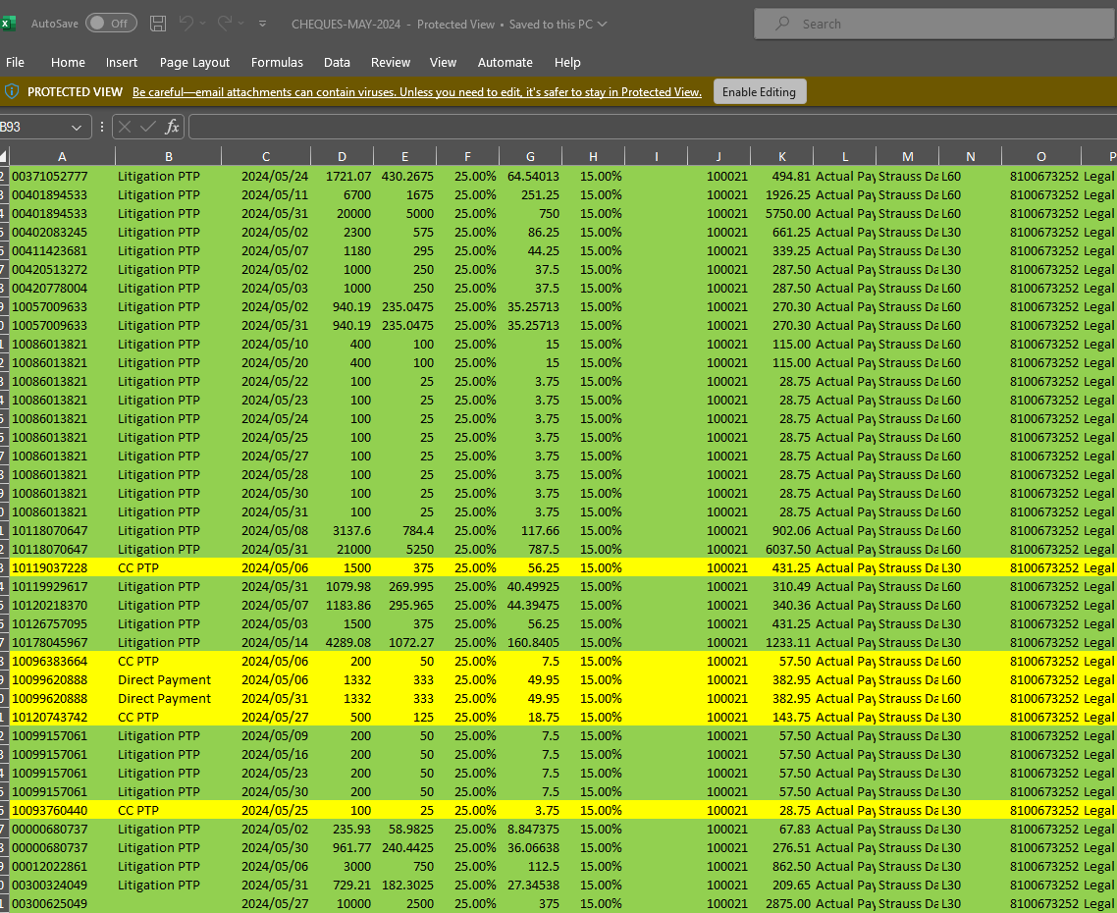
- Insert a column to the left of the account number column and name the column Iconis.

- If there is no data for both the Call centre or Litigation, mark that as Direct payment.
- Highlight all payments allocated to Ligitation in green.
- Highlight all payments allocated to the Call Centre in green.
- Highlight all payments allocated to the Direct Payments in green.

- Balancing

- Balancing must be done every Friday
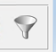
- Click on Filter

- Select Collections as matter type

- For client code search for the below and tag them

- STD9
- DRR9
- STA387
- DR387
- STA482
- DR482
- STA822
- DR822
- STA614
- DR614

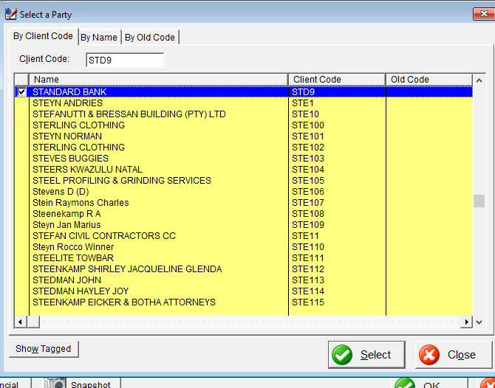

- Once all client codes are tagged click select

- For archive status select LIVE

- Click ok

- This will filter to all live standard bank matters worked on by collections

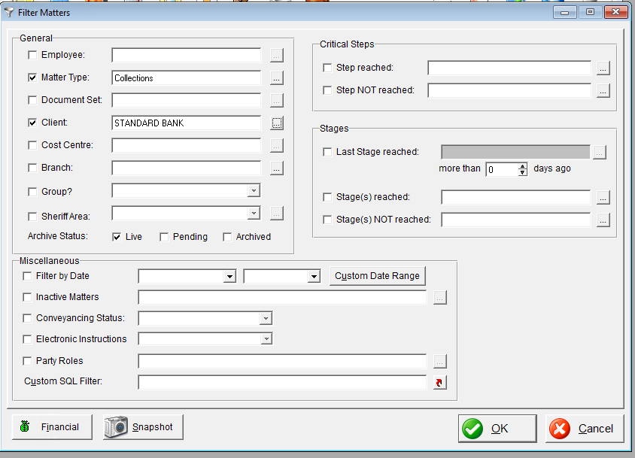

- Print Icon Button -  ADHOC REPORT
- Print - matter file ref,
- Print

- Copy matter file ref column

- Open Panel L Claim file
- Remove Matter and Claim amount column

- Paste Matter file ref column next to the file ref column

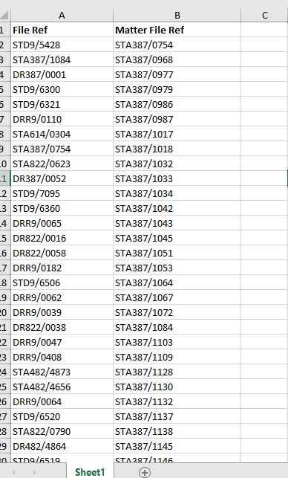

- Select both columns -> conditional formatting-> highlight duplicate values

- Any references not highlighted search for on the weekly balancing file

- If matter is closed but open on lsw, close the matter

- If matter is open but closed on lsw open the matter

- If the matter is not on the claim file or weekly balancing file leave matter in the state it is in, a closure or reopen file will be provided and then action can be done on that matters status.

- LEGAL SUITE ONLINE
Access using below link:
https://online.legalsuite.net/

login ID: SUP2
Password: 2468
Company: STRAU01
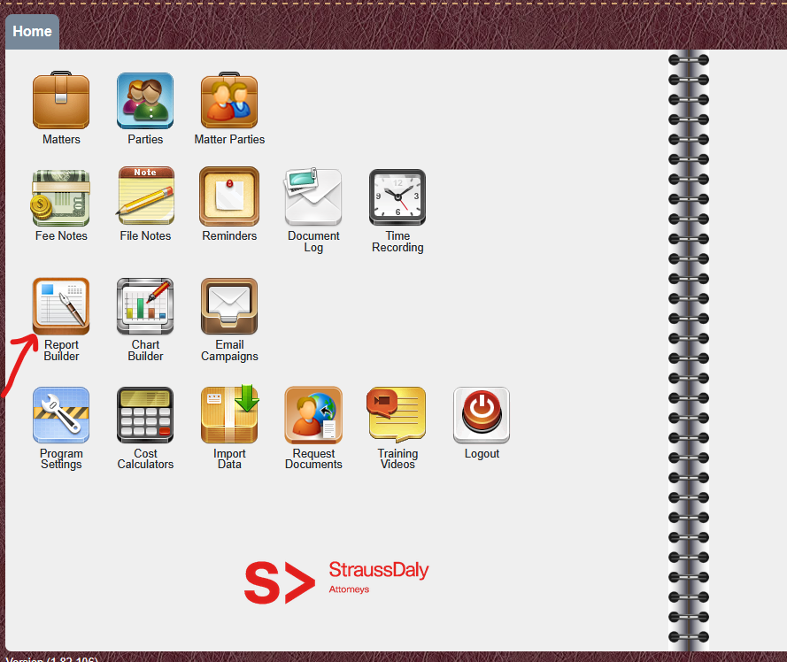

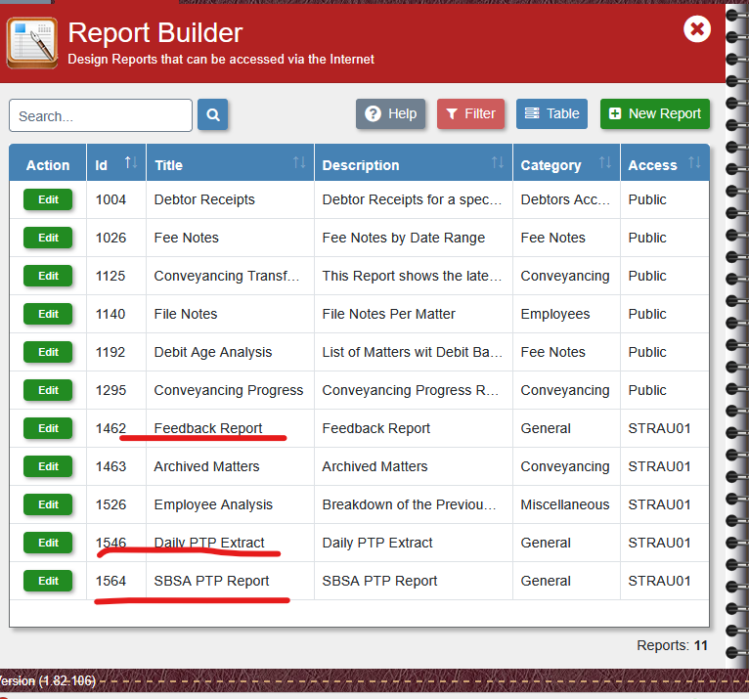
Navigate to report builder

The highlighted are the automated files that are sent out

Feedback and PTP Extract- Daily
SBSA PTP Report- Weekly (Every Monday)

